Regulations:
A14

H.T No

Sreenidhi Institute of Science and Technology
(An Autonomous Institution)
Code No: 4B202 Date: 11-Jan-2019 (FN)

B.Tech I-Year II-Semester End External Examination, Dec-2018/Jan-2019 (Supplementary)
Engineering Drawing – II (Common to All)

Time: 3 Hours Max.Marks:70

Note: a) No additional answer sheets will be provided.
b) All sub-parts of a question must be answered at one place only, otherwise it will not be valued.
c) Missing data can be assumed suitably.

Part - A Max.Marks:20

Answer all QUESTIONS.

1. | A distance of 3 cm measured on a map corresponds to an actual distance of 450 meters. Calculate Representative Fraction. | [2M]
2. | Draw the outline of a diagonal scale showing the meters, deci meters and centimeters. | [2M]
3. | Draw the isometric view of a cylinder of diameter 40mm and height 40 mm and is resting on H.P. | [2M]
4. | Draw the isometric view of a cone of diameter 30mm and height 25 mm and is resting on H.P. | [2M]
5. | Draw the development of a square prism of base 30mm and height 30mm. | [2M]
6. | Draw the development of a cone of base diameter 20mm and height 40mm. | [2M]
7. | Draw the Front View of the figure given below.  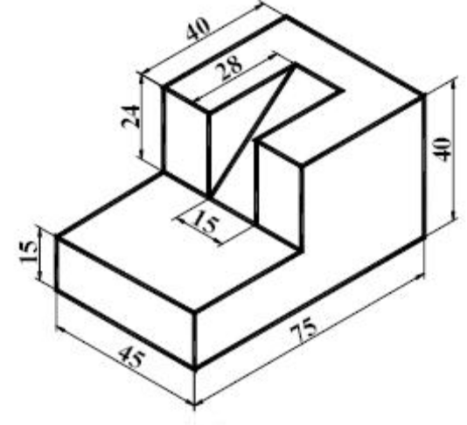 | [2M]
8. | Explain various elements used in perspective view. | [2M]
9. | What is the difference between the perspective view and orthographic view? | [2M]
10. | What is the use of line command in CAD? | [2M]
Part – B Max.Marks:50
ANSWER ANY FIVE QUESTIONS. EACH QUESTION CARRIES 10 MARKS.

11. |  | Construct a vernier scale of R.F.= 1/25 and long enough to measure up to 4 m. Show 3.14 m and 0.28 m lengths on the scale. | [10M]
12. |  | Construct a diagonal scale of R.F. = 1: 32,00,000 to show kilometers and long enough to measure up to 400 km. Show distances of 257 km and 333 km on scale. | [10M]
13. |  | A Pentagonal pyramid, base 25mm side and axis 65mm long, resting on the ground on its base with a side of the base parallel to V.P. The sectional plane is inclined at 45⁰ to H.P. and cuts the pyramid at the centre of the axis. Draw the development of lateral surface of the remaining portion of the pyramid. | [10M]
14. |  | Draw front view, top view and a side view for the solid whose isometric given below.  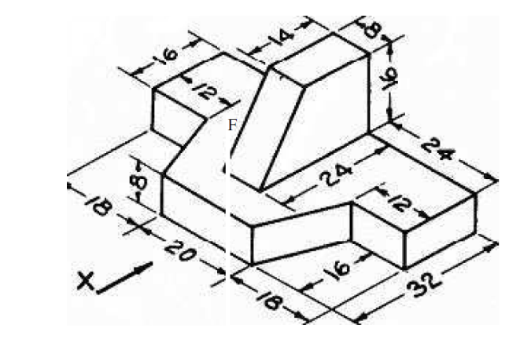 | [10M]
15. |  | Draw front view, top view and a side view for the solid whose isometric given below.  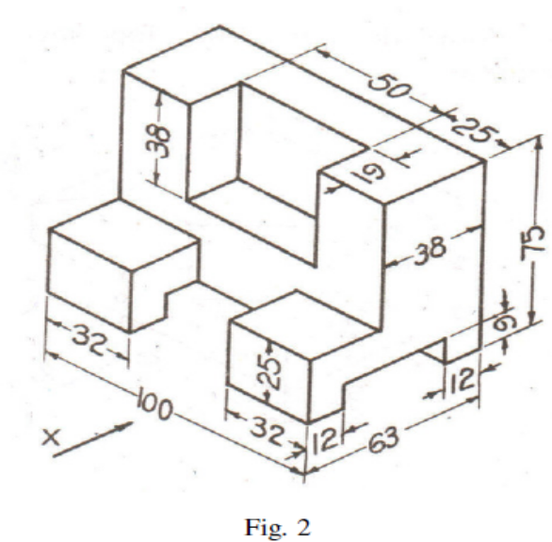 | [10M]
16. |  | Draw the isometric projection the frustum of a hexagonal pyramid is of bottom edge 50 mm, top edge 25mm and height 50mm. It is resting on its base on ground and an edge of the base is parallel to VP. | [10M]
17. |  | A straight line AB 60 mm long is parallel to and 25 mm above the ground plane and inclined at 30⁰ to the picture plane. The end A is 20 mm behind the picture plane. The station point is 50 mm above the ground plane and 40 mm in front of the picture plane and lies in a central plane which passes through the midpoint of AB. Draw its perspective view. | [10M]
18. |  | What are the input and output devices used in CAD? | [10M]

-- 00 -- 00 –

